1. As we can see from the bar graph on top, the industries which have seen the most growth are Consumer Products and Services, IT services, Health, Advertising and Marketing.

Actual graph provided below:



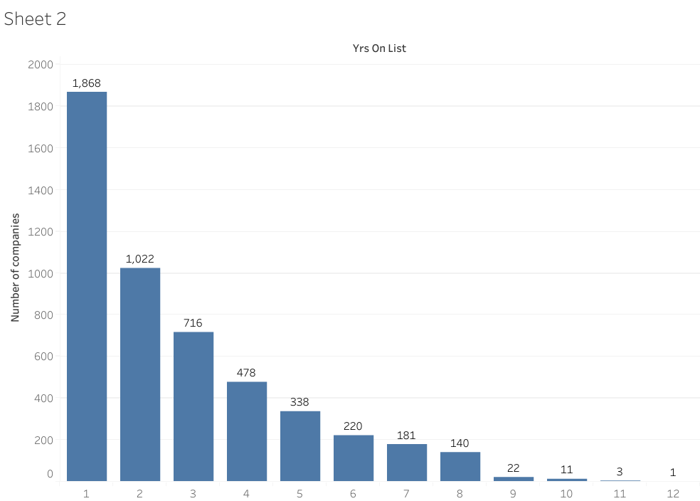

1. What the bar graph above shows us is the number of companies that have been on the list and how many years they have been on that list (from 1 to 12 years).

As we can see from the graph, the number of companies decreases significantly as the years increase. At 1 year there are 1, 868 companies on the list as apposed to 12 years, where there is only 1 company on the list.

So, to answer the question of whether or not companies that have been on this list longer have a higher chance of reappearing on the list. The answer is no. What we’re seeing is that if fewer companies have longer tenures on the list, it suggests that maintaining a spot on the list over consecutive years is challenging. The longer a company has been on the list, the harder it might be for it to reappear in subsequent years.

Graph provided below:



1. According to the scatter plot graph above, the data shows that companies with higher amounts of workers do not directly correlate to a high amount of growth. In fact, the opposite is actually true, where four companies with less than 250 workers have shown the highest degree of growth.

What we can conclude is that companies with less than 800 workers definitively show more growth than companies with over 1300 workers. This could be due to the relative growth that newer companies are able to achieve as apposed to larger companies, whose growth spurts have already happened and who have now understandably plateaued.

I have provided the actual tableau workbook below for interaction:



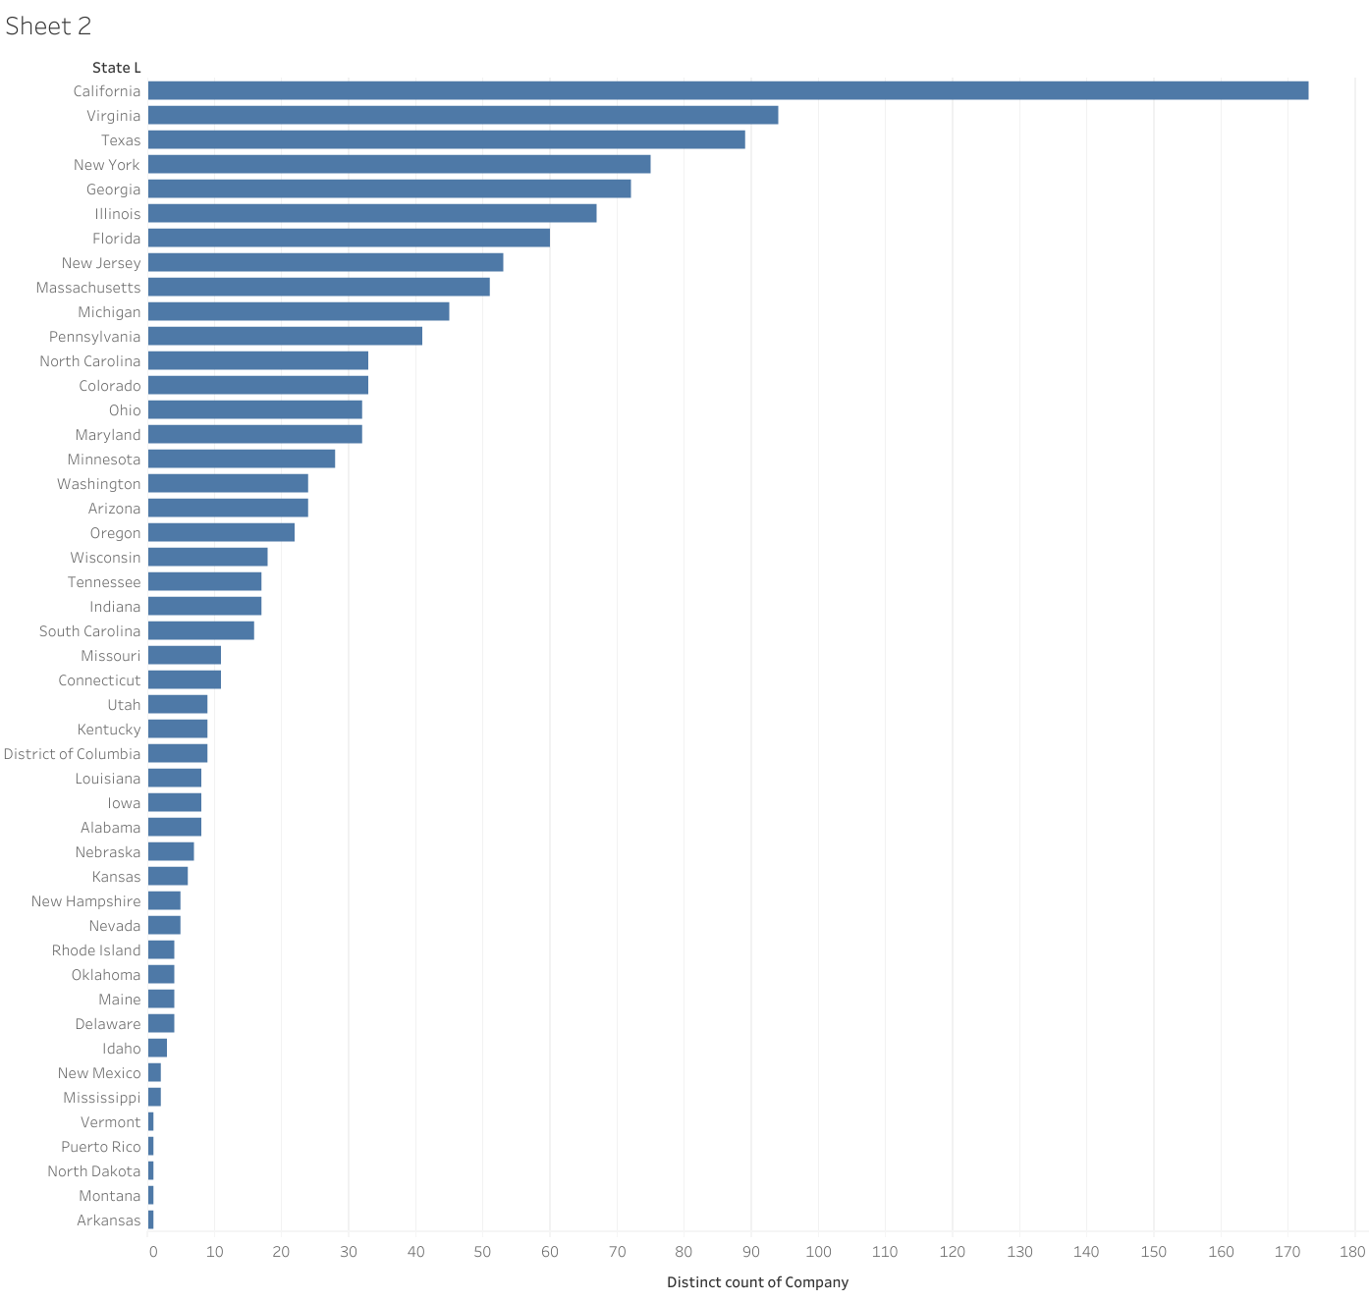

1. The horizontal graph above tells us that California is the state which holds the most IT companies (173 IT companies).

The actual graph is provided below:



1. As we can see from the horizontal bar graph above, the cities which have seen the most growth are Maynard, El Segundo, Palmetto, Fairhope, and North Richland Hills.

Graph provided below:

